LAB 2: Setting Up the Database Context for a Retail Store
Aim
To configure the Entity Framework Core DbContext and connect a .NET Console Application to SQL Server.

Objective
- Create Product and Category models.
- Configure DbContext.
- Connect the application to SQL Server.
- Generate and apply database migrations.

Tools Required
- Visual Studio Code
- .NET SDK
- SQL Server Express
- SQL Server Management Studio (SSMS)
- Entity Framework Core

Procedure
Step 1: Create Entity Models
Created Product and Category model classes with the required properties and established a one-to-many relationship between them.

Step 2: Configure DbContext
Created InventoryContext by inheriting from DbContext and added DbSet<Product> and DbSet<Category> for database mapping.
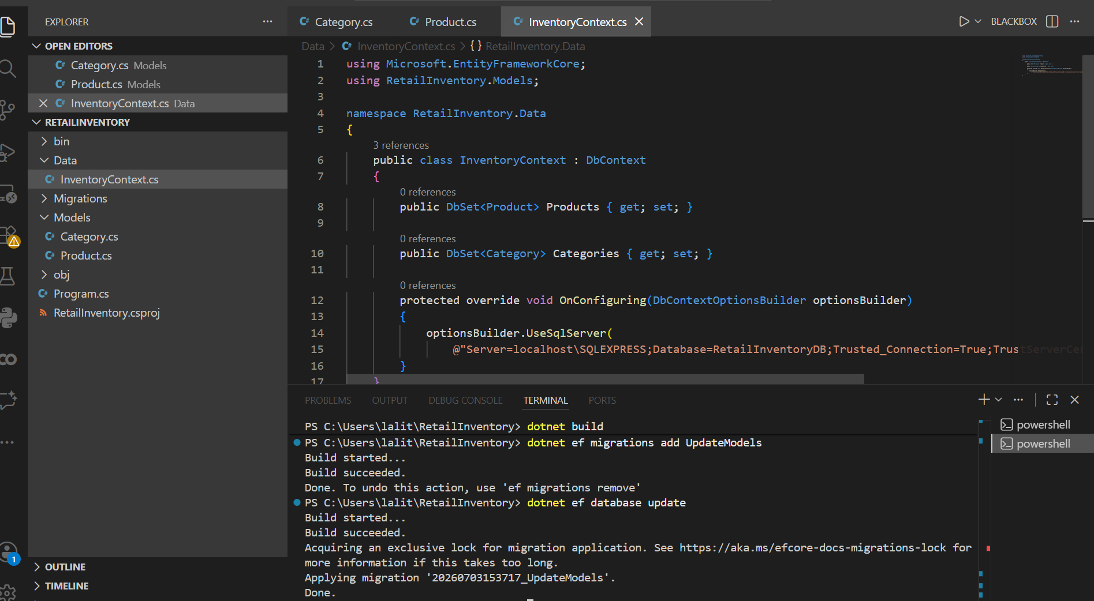
Step 3: Configure SQL Server Connection
Configured the SQL Server connection using the UseSqlServer() method and the appropriate connection string.

Step 4: Create Migration
Executed the migration command to generate migration files based on the entity models.
dotnet ef migrations add UpdateModels
Step 5: Update Database
Executed the database update command to apply the migration and create/update the database schema.
dotnet ef database update
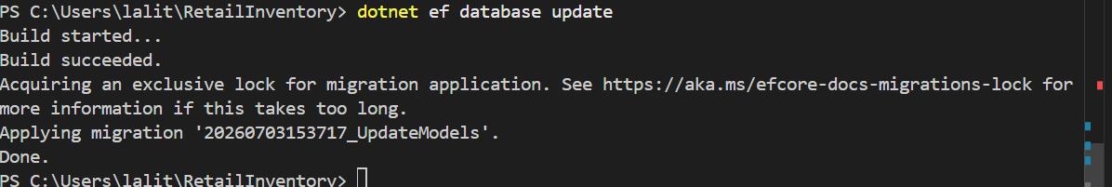
Step 6: Verify Database
Verified that the Products and Categories tables were successfully created in SQL Server Management Studio (SSMS).
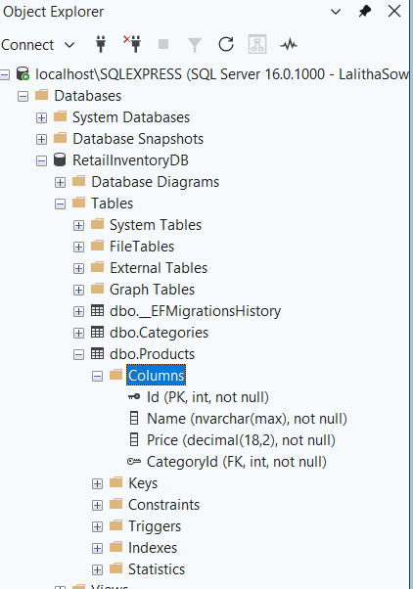

Result
The database context was successfully configured using Entity Framework Core. The Product and Category tables were created in SQL Server, and the application was successfully connected to the database.

